Create a Distribution List (DL) from CSV on Office 365

Hi There,

This script will help you to create Distribution Lists (DL) from a CSV file and will hide all those DLs (Distribution Lists) from the GAL (Global Address List).

We had to use a similar script to create Temporary DLs during a migration process (with similar names however with -Mig on its name).

You can also combine this script with another one to add members to DL (Distribution Lists) as well.

**Testing the csv file:**

*Import-Csv .\create-dl.csv*

**You should see the following**

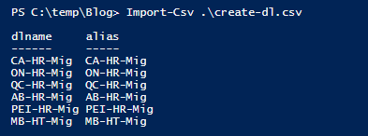

**PowerShell**

###########################################################################################

# Author Thiago Beier thiago.beier@gmail.com

# Version: 1.0 - 2020-FEB-28

# Create a DL (Distribution List on Office 365) from CSV file

# Toronto,CANADA

# Email: thiago.beier@gmail.com

# https://www.linkedin.com/in/tbeier/

# https://thigobeier.wordpress.com

###########################################################################################

**Import-Csv** .\create-dl.csv | **foreach** {

write-host "Creating DL:" $_.dlname -ForegroundColor Blue

write-host $_.dlname -ForegroundColor green

New-DistributionGroup -Name $_.dlname -Alias $_.alias -**Type** security

write-host $_.alias -ForegroundColor Yellow

Set-DistributionGroup $_.dlname -HiddenFromAddressListsEnabled $True

}